FOR IMMEDIATE RELEASE

USRC and Regional Partners Announce Oyster Harvest Rotational Pilot Program

Chestertown, Md. (October 25, 2021) - The Upper Shore Regional Council (USRC), in partnership with the Kent County and Queen Anne’s County Oyster Committees and the Maryland Department of Natural Resources (DNR), is pleased to announce its Oyster Harvest Rotational Pilot Program. Bolstering the economic and ecological sustainability of the region, approximately 14 million oyster spat (oyster larvae) have been planted in a 4.5-acre section of water in the region. The initiative aims to create a self-sustaining oyster program to benefit commercial watermen and the aquatic ecosystem.

Commercial fishing is a $5 million dollar annual industry sector along Maryland’s Eastern Shore. Given its importance to the region, Jason Ruth, co-owner of Harris Seafood Co., who assisted with design and planting, hopes the project will generate revenues for watermen and pride in the waters that sustain them.

“The USRC project will help advance a new process for watermen to take a greater responsibility in maintaining a biomass of oysters while being able to be financially stable at the same time,” Ruth observed.

Funds generated from the first spat will fund the next set of spat plantings, eventually resulting in a self-sustaining oyster population. In recent decades, oyster populations have declined, due to overharvesting, pollution, and disease. As habitats for fish and crabs, oyster reefs provide nourishment and natural protection from predators. By creating new harvests and reefs, the program will restore the vitality of the ecosystem.

Christopher Judy, Director of the Shellfish Division for the Maryland DNR, emphasizes the project’s benefit to local waters. “There is a definite impact for both the Chester River and the local oystermen,” he noted. “The oysters planted on Coopers Hill will grow and enhance the oyster bar community of fish and a variety of invertebrates—worms, mud crabs, and shrimp included.”

This collaboration between state, regional, county, and commercial partners strives to make the oyster industry strong and habitats healthy.

“This partnership brings together expertise and resources for the benefit of our waters—and our watermen,” said Susan O’Neill, Executive Director of USRC. “When we combine efficiencies and ideas, we can solve regional challenges.”

Christopher Judy agreed. “The project is an example for others, showing how groups can work together to develop projects with both ecological and economic benefits. It doesn’t have to be a situation of ‘either/or,’ or ‘my way or the highway.’ It can be a team effort with diverse benefits.”

For updates on the Oyster Harvest Pilot Program, please visit the USRC website.

###

About the Upper Shore Regional Council
Since 2003, the Upper Shore Regional Council (USRC) has fostered planning and development in Cecil, Kent, and Queen Anne’s counties. USRC affords federal, state, county, and local governments a regional forum to identify issues and opportunities. USRC plans and implements programs to improve the quality of life in the Upper Shore Region of Maryland.

IMAGE
https://www.dropbox.com/s/eu8k3qplnchjfu7/PICT1935.JPG?dl=0

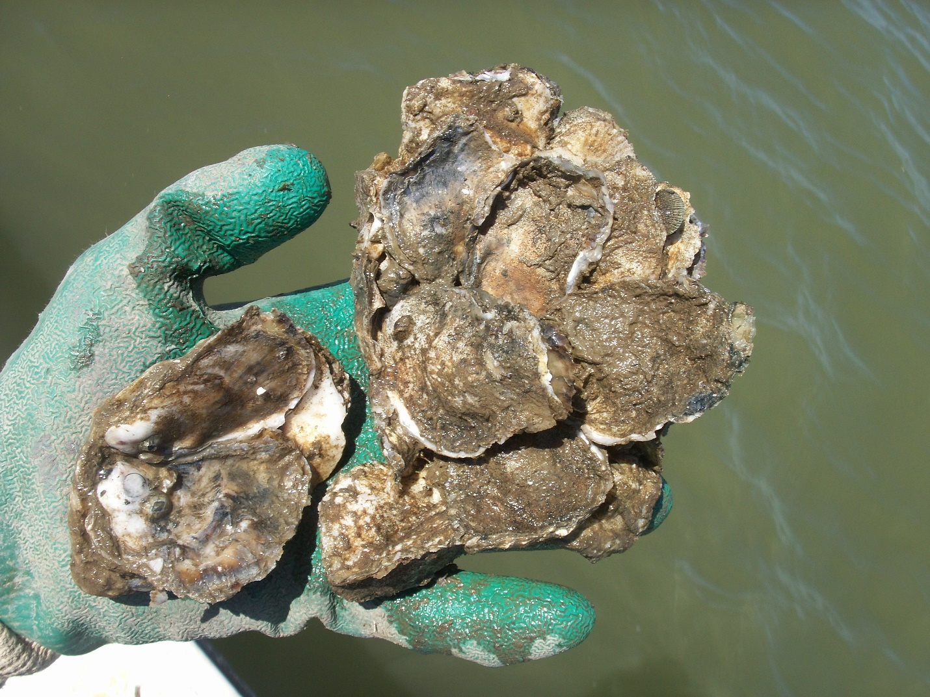

Media Contact
Ellen Buchanan
Ellen@platinumpr.com
301-360-3506, ext. 104

